Meta Description:
Off-Page SEO is referred as optimization done outside the website with focus on Building authority and reputation through Backlinks and social media.
https://drive.google.com/drive/folders/1KMrJ-5ro7ioc90NVjKz_acN5Xb-Xf8-p

What Is Off-Page SEO & How to Do it Effectively in 2025
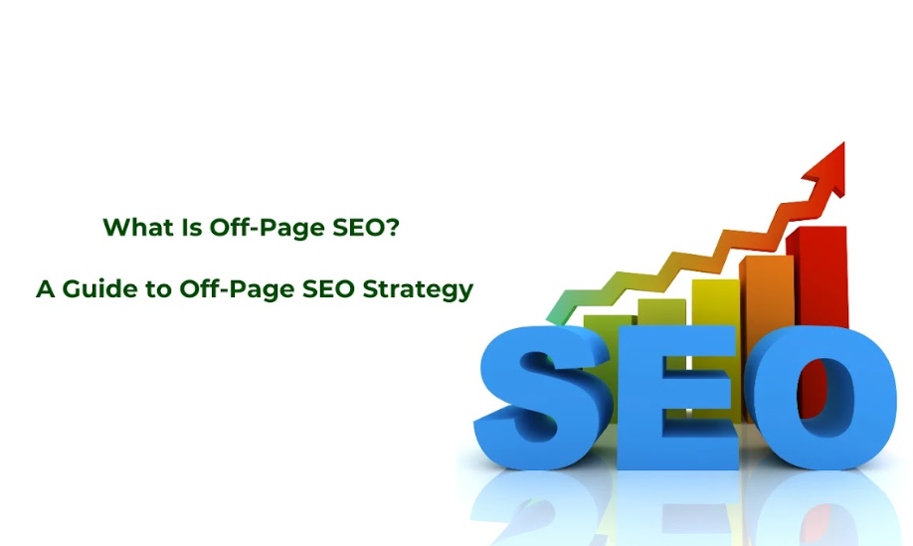
In Search engine optimization, there are two types of activities involved one that occurs inside the website boundaries and the other one outside the website boundaries. Off-page SEO is those activities that occur beyond your website space and affect your website search position ranking and visibility.
Here you will learn about what it is and how to do it effectively in 2025 and beyond.

What is Off-Page SEO: Core Concept and Its Role in Search Engine Optimization
Off-Page SEO refers to activities that influence your website's position on search engine results pages (SERPs) through activities performed outside of your website. Search engines use external data to evaluate your website's authority, relevance, and trustworthiness instead of internal factors such as Site structure, Content Quality, and HTML source code.
Here are some major external factors that carry great significance:
- Backlinks: Links that other websites pointing to your site to share traffic
- Brand mentions: External website mentions that point to your website's URL
- Social signals: Level of Engagement of your content on different social media platforms
- Local citations: Your business information like name, address, and phone number on directories and listing sites
- Reviews: Customers feedback on Google Business Profile, functional websites, social media as well as industry-related platforms

Purpose of Off-Page SEO: Enhancing Website Authority, Trustworthiness, and Visibility Beyond On-Site Efforts
Off-page SEO aims to achieve multiple business goals beyond ranking enhancement at the start of 2025. Some of these goals are explained below:

Establish Domain Authority
Google looks deeper than content by checking how external websites recognize your web pages. Off-page SEO relies on different techniques to prove your website's authority in your industry by building positive relationships with other companies.
- Endorsements from recognized industry leaders
- Citations in academic or professional publications
- Links from relevant, high-authority websites
- Expert contributions to established platforms
A recent research reveals that powerful authoritative websites gain listings for a wider selection of keywords regardless of new content additions to their destinations.

Build Trust Signals
User trust now decides search results and off-page activities show search engines how much users can rely on your site. Here are different ways to build that trust:
- Consistent positive reviews across multiple platforms
- Verification through industry associations and certifications
- Mentions from relevant trusted news sources and publications
- Social proof through engagement and recommendations
When users search for any information, search engines look at these trust signals to find whether your website is worthy of ranking or not.

Expand Brand Visibility
There are a lot of strategies and tactics that off-page SEO implements to create multiple touchpoints through which any user can find your brand easily even in a tough competitive environment. Let’s understand how Off-page SEO does it:
- Create a stronger presence on social platforms through conversations
- Target relevant publications which mostly read by your target audience
- Increase Visibility on citation networks through local searches
- Proper representation in industry directories and resource lists
An increase in online exposure of your brand will improve traffic rates because more people will recognize your brand and click more often.

Create Resilience Against Algorithm Updates
The stability of your website during search algorithm changes grows more when you have a collection of different high-quality off-site profiles. You can build resistance against algorithm updates for your website through a variety of natural external references that shield your online performance.

On-Page SEO vs. Off-Page SEO: A Detailed Comparison
Understanding the distinct yet complementary nature of on-page and off-page SEO is essential for creating comprehensive optimization strategies. These two branches of SEO work together to improve visibility and rankings but focus on different aspects of the search ecosystem.

Key Differences: Focus Areas, Strategies, and Outcomes
Your SEO strategy needs to balance the Off-page and Off-page SEO if you want to get good results. These two types of SEO will improve search results but operate in separate sections of the digital system. Let’s understand the difference between both types based on the focus area, strategies, and outcomes:
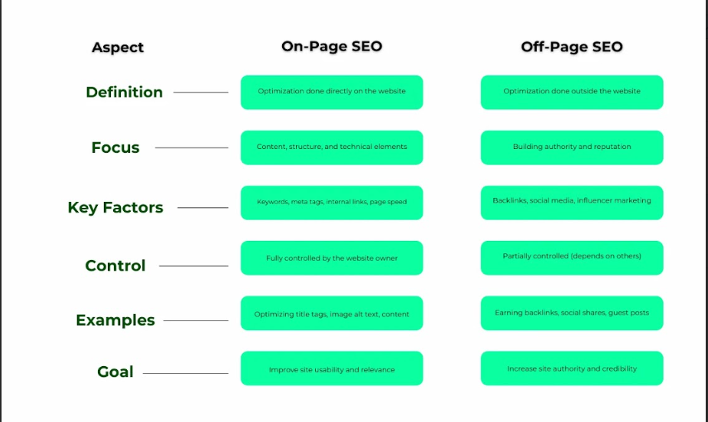

Focus Areas:
The focus area of On-Page SEO is on elements that are directly within control of your website such as:
- Keyword optimization and content organization
- Content quality and relevance
- Schema markup and structured data
- Page loading speed and performance
- HTML source code optimization (title tags, meta descriptions, header tags)
- URL structure and site architecture
- Internal linking patterns
- Mobile responsiveness and usability
On the other hand, Off-Page SEO handles aspects beyond your website to show search engines about your site reputation and subject alignment.
- Influencer relationships and partnerships
- Social media presence and engagement
- Local citations and directory listings
- Online reviews and reputation management
- Brand mentions across the web
- External link building and acquisition
- Content distribution and syndication
- Guest blogging and external content contributions

Strategic Approaches:
In the case of strategic approach, both types rely on different operating methods or approaches:
On-Page SEO Strategies typically involve:
- Content gap analysis and fulfillment
- Content updating and freshness maintenance
- Comprehensive content creation based on keyword search volume
- Technical optimization of website elements
- User experience improvements
- Internal linking optimization
- Site architecture refinement
On the contrary, Off-Page SEO Strategies focus on:
- Reputation management across multiple platforms
- Relationship building with industry peers
- Community engagement and industry participation
- Content promotion to relevant audiences
- Strategic partnerships with complementary businesses
- Digital PR and brand awareness campaigns
- Authority building through knowledge sharing

Measurable Outcomes:
Although the end goal of both types is the same which is to increase traffic and conversion rate, let’s understand how each type contributes to the overall growth and performance of a website.
If we talk about On-Page SEO, it typically impacts:
- Site health and technical performance
- Keyword rankings for specific pages
- Organic click-through rates
- Rich snippet visibility in search results
- Time on-site and bounce rates
- Crawlability and indexation rates
- Page-level conversion rates
Off-Page SEO more directly influences the following outcomes:
- Overall ranking potential across all web pages
- Domain authority and trust metrics
- Brand visibility and recognition
- Referral traffic from external sites
- Social traffic and engagement
- Brand search volume
- Local search performance

How On-Page and Off-Page SEO Complement Each Other
Although there is a huge difference between both, still both on-page and off-page SEO create a connected system that works together.

Content Quality Drives Link Acquisition
Content that people want to see forms the basis that helps off-page SEO achieve its goals. Good content makes link building and social sharing easier because good content naturally attracts these activities. When content matches user requirements it naturally generates links from other websites and convince people to share it on different platforms.

Link Authority Amplifies Content Visibility
To reach its highest-ranking position content needs important signals from outside sources. Search engines find and evaluate on-page content better when it receives important backlinks. Research reveals that on-page content gets better search rankings because more quality backlinks appear on the page.

Technical Foundation Supports Off-Page Value
On-page technical requirements ensure link importance and authority signals flow correctly across the Internet. Search engines cannot accurately evaluate your content if technical problems related to broken links or slow pages exist during your off-page promotion.

User Signals Reinforce External Authority
On-site user interaction data tells search engines how users respond to a certain website. Strong external signals drive better user interactions, which build a positive pattern that accelerates ranking improvements.

The Importance of Off-Page SEO: Key Reasons
Off-page SEO stands as a main part of search visibility tactics because search engines now evaluate website quality and relevance before providing a ranking. By knowing how off-page SEO works, you can strongly guides your business decisions about spending resources on vital tasks efficiently.
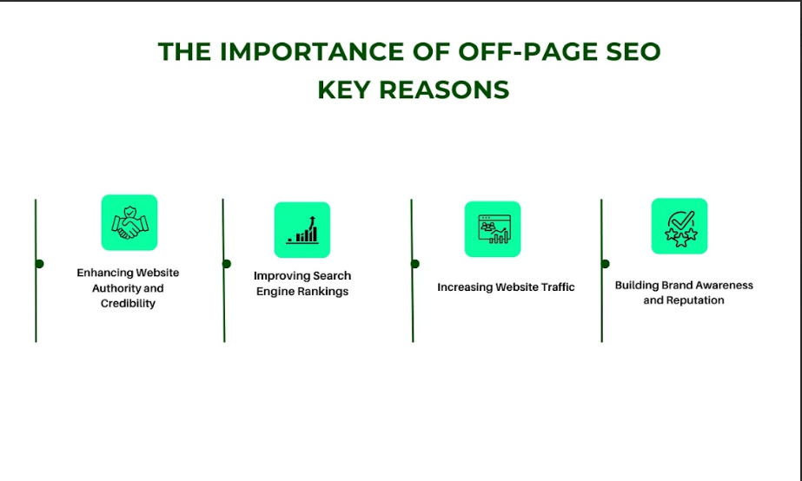

Enhance Website Authority and Credibility
The search engines differentiate high-ranking websites from their competitors on the basis of website authority and credibility which mainly depend on traffic from other sites.

Building Topical Authority Through External Validation
Search engines determine the authority of a website based on references from outside sources.
- Received links from established sites that focus on this subject
- Mentions in authoritative industry publications and academic sources
- Citations in research papers and professional resources
- References from recognized industry experts and thought leaders
Search engines use these signals to locate your website position among the other industry knowledge sources. A site with established topical authority gets listed for multiple search terms when it adds new content even if it targets high-difficulty keywords.

Establishing Trust Through Third-Party Endorsements
Trust from website users now plays a larger role in search results and third-party endorsements serve as the most essential trust signals.
- Positive reviews across multiple platforms
- Endorsements from industry certification bodies
- Mentions in trusted news sources
- Verification through professional associations
- Recommendations from respected individuals in your field

Improve Search Engine Rankings:
Off-page factors determine your site ranking by helping search engines understand the credibility of your website through multiple means:

Direct Ranking Signal Impact
Different off-page criteria have straight effects on your site rankings.
- Different websites need to connect to your site from many authoritative online sources at various positions.
- Online sites that share links with yours share a lot of authority
- Your brand name brings value when people talk about it in their online posts.
- User engagement metrics from external platforms
Research demonstrates that quality backlinks maintain their place as top three significant elements for ranking success in different market sectors.

Competitive Differentiation in Saturated Markets
When several websites have optimized their main content equally off-page factors decide which one ranks highest.
- Review quantity and quality often determine local pack rankings
- Websites with more powerful links can outperform content depth when both elements are close.
- Strong brand signals help to distinguish between similar niche sites
- Local citation accuracy can be a decisive factor for location-based searches
On-page SEO now become a standard practice among companies that use off-page strategies to establish a clear leadership position over market competitors.

Increase Website Traffic
When you enhance the way, users discover your content online you get more web traffic directly from additional sources beyond basic search position.

Diversified Traffic Sources:
You will attract more users when you build a complete strategy for off-page features, which is as follows:
- Gain traffic from third-party review platforms and marketplaces
- Get referral traffic from backlinks placed on high-traffic websites
- Rely on social traffic from content sharing and engagement
- Try to get Direct traffic from brand mentions and citations
- Obtain Local traffic from directory listings and map placements
Having website visitors enter through various channels protects against sudden ranking shifts while offering more ways to generate sales.

Expanded Audience Reach:
Traditional Off-page marketing methods help your brand reach new potential customers directly. Some of these methods are as follows:
- Guest posts help your brand reach established audiences on other platforms
- Your content reaches more people through social interactions with followers of those involved.
- Community participation builds visibility with niche audience segments
- Local citations help you capture location-based discovery opportunities
- Business listing services help you find specific customers from your industry field
Greater exposure points trigger brand awareness which leads to more direct brand searches by new clients.

Build Brand Awareness and Reputation
Off-page SEO efforts benefit your brand totally by providing results that Google cannot track directly. Such benefits are related to brand awareness and reputation:

Brand Recognition Enhancement:
Repetition in online platforms builds connections in people's minds that affect how they behave as your customers. Through this repetition, you can easily enhance the engagement level of your brand in the market.
- A brand becomes more founded in people's minds when it stays visible across different internet platforms.
- A brand builds stronger relationships through brand associations.
- When outside sources mention your company, they strengthen your industry presence and build your trustworthiness as a business.
- Industry participation also establishes your business's professional credibility
- Local visibility of your brand reinforces its community connections
You know very well that in most cases searchers tend to pick results from known brands even if these items are lower in display ranking because of their recognized names.

Reputation Management and Perception Control
Your website's Off-page actions will determine what your customers think about your brand in the market.
- Proactive review generation showcases Your customer satisfaction
- Your Quality content placement creates industry leadership status
- Community outreach shows how your company stands for values and unique traits
- Your Public relations campaigns show the achievements and accomplishments of your company.
- You can create a positive image and better social connections through social responsibility programs.
When customers already trust you, they tend to convert easily through your website and enjoy longer relationships.

How to Master Off-Page SEO Techniques in 2025?
Every online business now needs off-page SEO to gain better online results and build more authority in the digital space. The main off-page strategies in 2025 depend on creating real interactions with value content plus working towards better connections.
Here we will highlight what off-page SEO methods actually work in 2025 so companies of all sizes can establish stronger digital presence while growing their organic search placement.

1. Strategic Backlink Acquisition
The basic strategy of successful off-page SEO still relies on obtaining good backlinks from target sites. Internet users in 2025 no longer base their rankings on the number of backlinks yet rely heavily on link profiles from trusted sources.

Techniques: Guest Blogging, Resource Pages, Broken Link Building

Guest Blogging Reinvented
Although guest blogging brings results in 2025, yet it needs to be managed more carefully. To succeed your company needs to target a small number of key industry publications and create sustainable partnerships that deliver quality results.
The key differences that a successful guest post includes strategies like:
- Topic alignment with target audience search intent
- Clients like content based on data that reveals fresh information
- Mix text materials with visual materials for better engagement
- Long-term contributor relationships rather than one-off posts
Research demonstrates higher success when companies submit three to four premium guest posts per month on recognized websites versus distributing between fifteen and twenty weak ones.

Resource Page Link Building
Resource pages provide quality chances to get backlinks naturally. Special collections of useful resources are developed and managed by universities, government bodies, industry groups, and experts in their fields.
To leverage resource pages effectively you need to consider aspects like:
- Develop useful information sets that meet distinct professional specialty requirements
- Reach out to maintainers of resource pages with customized approach requests
- Tell them exactly where your content will improve their missing resource information
- Keep reaching out to maintain your links while updating resources to benefit customers and build better partnerships

Broken Link Building
Start your search for broken links on related sites and then recommend your content to replace them. By 2025 this approach has reoriented to emphasize publishing helpful and suitable content.
- Find industry-broken links using tools like Ahrefs, Semrush, or Screaming Frog for link-building results.
- Make better replacement content that deeply surpasses what exists already
- Explain precisely what your material brings to the site owner's visitors.
- Offer content in options like full guides and graphics plus interactive design elements

Tools and Best Practices for Effective Link Building
In 2025 effectiveness of link building strategies depends on using complete technology platforms as part of the campaign.
- Relationship management tools: CRMs help professionals track and support their outreach activities through relationship management tools
- Content analysis platforms: Help detect AI-based content that needs improvements and find opportunities to improve results
- Authority metrics: Analyzes more advanced measurements to determine authority beyond basic DA/PA data
- Natural link pattern monitoring: Tools that flag potentially problematic link acquisition patterns
Our best working methods generate steady results through these actions:
- Creating valuable content makes it easier to earn linked-back online references
- You should craft adjustable outreach materials that deliver your message consistently.
- Activate your outreach campaigns step by step without overburdening the target person or party.
- You must measure your link-earning success for each part of development.
- Constantly review your website links to locate problem links at the start

2. Leverage Content Marketing for SEO
Content quality leads to both content marketing and off-page SEO practices which now work closely together to earn natural links from other sites.

Role of High-Quality Content in Off-Page SEO
High-performing content in 2025 shares several characteristics about which you must be aware of:
- High-level knowledge to resolve unfulfilled content needs
- Incorporation of original research or proprietary data
- Multi-format presentations (text, video, interactive elements)
- Regular updates to maintain relevance
- Strategic internal linking to distribute link equity
You will receive organic backlinks when your content answers specific industry questions while offering problem-solving solutions and presenting new ideas with evidence.

Techniques: Infographics, Guest Posting, Content Distribution

Infographics and Visual Assets
Visual assets will help your websites gain traffic and links. Here are some effective visual asset strategies you should include in your Off-page tactics:
- Use original research to make industry benchmarking infographics
- Build clear visual models to explain difficult business topics
- Produces visual content that captures audience interest and shares meaningful data experiments
- Create brief images that work well on social platforms for easy sharing
To achieve better results, you need to make sure that you break down all complex infographics into your content into smaller and simpler ones. Make sure you follow the color scheme of your brand in your infographics.

Strategic Content Distribution
Content distribution now requires more advanced methods than basic posting or sharing. Here are some of the most effective content distribution strategies, you need to incorporate:
- Set different plans into action to target different audience segments effectively
- Craft Platform-specific content rather than identical cross-posting
- Share your content in relevant online communities to grow your audience
- Use paid methods to make content spread more easily within natural sharing systems
In most cases, organized brands distribute and promote their created content between 40% to 60% of their total budget. This strategy will them to attract more audience engagement and backlinks.

3. Optimizing for Local SEO
In 2025 local SEO needs more detailed focus because search engines emphasize more on how close a business is to users. Additionally, search engines also check if the location matches users search results and if the company stands out above others.

Strategies for Local Businesses: Google Business Profile, Local Listings
Google Business Profile (formerly known as Google My Business) is one of the most essential platforms to get the maximum out of your local SEO strategies. Here are some local business strategies you can follow for better outcomes:
- Regular posting of updates, offers, and events (minimum 2-3 times weekly)
- Choose your business traits that make you stand out from competitors
- Respond to customer inquiries speedily (we answer within 4 hours).
- Use service groups and post product details as a strategic part of your business strategy
- Integrates message and scheduling functions into your system.
Businesses that receive the best Google search results now focus their efforts on making Google Business Profile their top marketing platform.
Here are other relevant local listing strategies you can follow to get better outcomes:
- Maintain consistent NAP (name, address, phone) information across all platforms
- Choose directories that fit the business category instead of signing up everywhere.
- Regular audit and update your business information
- Integration of enhanced features like appointment schedules to make users' experience better.

Leverage Local Citations and Online Directories
Local citation management continues to evolve with greater emphasis on quality over quantity:
- Focus on industry-specific and location-specific directories
- Prioritize directories that verify business information
- Maintain consistent business descriptions across all platforms
- Regularly audit and remove duplicate or outdated citations
The most successful local businesses are building comprehensive local content strategies that include:
- Location-specific landing pages with unique, valuable information
- Community involvement content highlighting local partnerships
- Local event coverage and participation
- Area-specific offers and promotions

4. Manage Online Reviews
Search engines now consider reviews more important than ever in off-page SEO because they use advanced technology to check how well you are viewed by customers.

Importance of Reviews in SEO and Reputation Management
Reviews help optimize SEO results in different ways such as:
- Volume and frequency of new reviews
- Overall rating distributions
- Keyword inclusion in review content
- Response rates and quality
- Review diversity across platforms
Search engines check patterns in reviews to find dishonest business practices and abnormal rating trends.

Encouraging Positive Reviews and Handling Negative Feedback
Through successful review generation strategies, your brand can easily maintain the balance between proactivity and authenticity.
- Implement post-purchase review request workflows with optimal timing
- Teach staff members to ask for positive feedback when customers reach high levels of satisfaction.
- Tell customers step-by-step how they can post feedback
- Respond to every review that customers submit regardless of feedback quality
- When dealing with criticized reviews your teams need to tackle each mentioned issue.
- Show customers how you acted on their solved problems to prove you are accountable
Study shows companies that respond to reviews in 24 hours or less gain more customers and sales success.

Ready to Master Off-Page SEO? Key Takeaways and Next Steps
The successful practice of off-page SEO in 2025 requires you to combine proven methods with new trends while focusing on high-quality results. Organizations that ignore off-page SEO find it difficult to enhance their rankings even when they improve their on-page content. Successfully ranking in search engines needs proper attention to search engine optimization methods. Here at Three Angle Marketing, we offer effective Off-Page SEO Services to our clients to help them achieve better results in no time.
Whether you are struggling to gain credibility or want to earn the trust of search engines, our Off-Page SEO Services in Dubai will never disappoint you.

